**Set Up Environment**

Purpose: In this lab, you will set up the key components on your system to use Python.

1. **Install Python Windows:**
   1. Go to [www.python.org/downloads/](http://www.python.org/downloads/)
   2. Download and install the latest version of Python
   3. From command prompt, type *pip install requests*
2. **Install Python for Ubuntu**
   1. Install C to compile
      1. *Sudo apt-get install build-essential*
   2. Install make
      1. *Sudo apt install make*
   3. Install libraries for python
      1. *sudo apt-get install libreadline-gplv2-dev libncursesw5-dev libssl-dev libsqlite3-dev tk-dev libgdbm-dev libc6-dev libbz2-dev*
   4. Go to Go to [www.python.org/downloads/](http://www.python.org/downloads/)
   5. Download latest Gzipped tarball
   6. Extract files into a directory of choice or use the default directory from the extract (usually Python-*RevisionNumber*), using Archive Manager or tar
   7. Change directory into the directory above
   8. Run the following:
      1. *Sudo ./configure –with-ssl*
      2. *Sudo make*
      3. *Sudo make test*
      4. *Sudo make install*
      5. *Sudo pip3 install requests*
3. **Idle3**
   1. On Linux:
      1. *Sudo apt-get install idle-python3.9*
      2. *Sudo apt-get install python3-tk*
      3. Run idle with *idle-python3.9*
4. **Google Postman**
   1. Create an account
   2. Download Postman from [**https://www.postman.com/downloads/**](https://www.postman.com/downloads/) and install (Can be Linux or Windows). Note where you install it
   3. Verify that you can open the Postman app.
   4. Postman can also be installed natively from Ubuntu for the Apps icon
5. **GIT**
   1. Install git on **Linux** by typing *sudo apt-get install git*
   2. On a **Windows PC**, download git from <https://git-scm.com/downloads/>
6. **GITHUB**
   1. Log into github and set up an account
   2. Login and create a private repository with a readme file
   3. Note the repository URL after you create your repository:

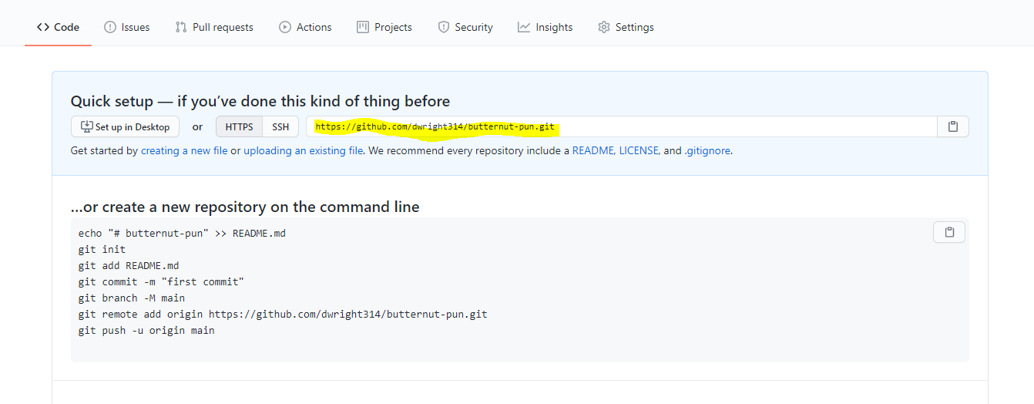

* 1. From Linux or Windows go to your command line
  2. Make sure you are in your home directory or another directory that you prefer to use. The command below is typed in the directory noted above
     1. *Git clone* *url*
        1. Note that *url* is your URL noted in the screenshot above for your repository (Note that the one above is my repository. You will need your own). For Linux users you will be challenged at the command line with your github credentials. For Windows users, you will be directed to your browser for authentication information
     2. Note your repository name. There is now a directory with that name in your current directory. Verify that it is there.
     3. Create a Hello World Python Script and save it in your repository folder
     4. To authenticate your account, type:
     5. git config --global user.email [you@example.com](mailto:you@example.com)
        1. ex: *git config --global user.email yourEmail@madisoncollege.edu*
     6. *git commit -m “Description of what you did”*
     7. *git push*
     8. To retrieve any updates type the following from within the repository: *git pull*

1. **Install PyCharm**
   1. <https://www.jetbrains.com/pycharm/>
   2. For Windows, Download and install latest version of pycharms Community
      1. Be sure to choose the following in the Windows Install

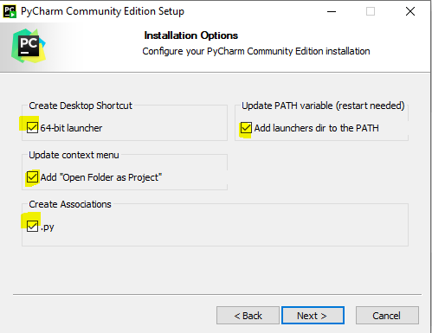

* 1. For Linux, Download and extract the files into directory of your choice
     1. Add a path (PATH=$PATH: dirPath) for the bin directory of the pycharm-community-x directory in the extracted directory you created above (ex: *tar xvf tarFileName*)
     2. Update the path in either the .bashrc user profile or etc/profile.d for all users with: *export PATH=$PATH:pathToBinOfPycharmCommunityDirectory*
     3. Run the following to launch pycharm: *./pycharm.sh*

1. **Cisco AnyConnect VPN Client**
   1. For Windows, download AnyConnect from [https://developer.cisco.com/site/sandbox/anyconnect](https://developer.cisco.com/site/sandbox/anyconnect/%20) and install
   2. For Linux, if you have a contract, download the AnyConnect Linux client
      1. Extract the files
      2. In the anyconnect-linux64-x/vpn directory, run: *sudo sh ./vpn_install.sh*
      3. Add path for VPN directory in .bashrc

Vendor Name: @Heavenstudios

-Product(S) Reviewed: a product.

-Sample or Order (S or O): Order

-Payment Method: sold my soul

-Customer Service (1-5): 99999999/5

-Product Quality (1-5): 99999999/5

-Product Consistency (1-5): 99999999/5

-Processing Speed (1-5): 99999999/5

-Price Value (1-5): 99999999/5

-Vendor Trust (1-5): 99999999/5

-Reorder Possibility (1-5): did you read my 99999999 scoring? HE IS THE MAN.

-Product Comparison: Dissos, 2bdck, 2fdck type

-Stealth and op-sec [XXXX]

-Vacuum-sealed []

-Properly sealed solution/baggies [XXXX]

-Decoy/misdirection [XXXX]

-Additional comments: Man, I can't vouch enough for this guy. His stuff is legit as legit can be. Their an awesome person overall. He went out of his way for me, and I will always remember that. Product came in less than a couple of days. Professional packaging. Stealth was def on point. Fast responder and the product is as pure as can be. I've never researched so little to figure out so much. Like I said, I can't vouch enough for this man. He is GOAT in my book. Has anything you might need for your lab and is very fast and discrete. No lies, no gimmicks. Just straight up what you ordered. Did I mention hes ONE HELL OF A DUDE too? Very nice vendor. Very chill, active, trustworthy. Amazing selection too.